**Project Report**

Dhayanidhi V

Sudharshan R

Aadhithyan P

**What we did?**

* Created an android mobile application using capacitor for downloading zip files using ionic framework. A Cordova plugin was used for downloading files. The Cordova provides a bunch of API’s from which we found use for the native download plugin.
* Capacitor was used to create android APK of the ionic project we developed, so we could test it on our phones.
* The custom android app was modified in order to retrieve files from Google drive and download them.
* The Google drive was populated with zip files containing images and text file.
* Uploaded files greater than 50MB to the Google drive and tested the same.
* Encountered errors about corrupted files with google drive. Figured out google drive was not able to scan files for virus greater than 27 MB.
* Figured out firebase had such no limitations and download link can be retrieved and the cloud storage up to 30GB.
* Sample files were tested with the firebase as server. We did multiples cases to figure out all possible test cases and encountered no error.
* Later we got the response to try out other measures as provided in the image below.

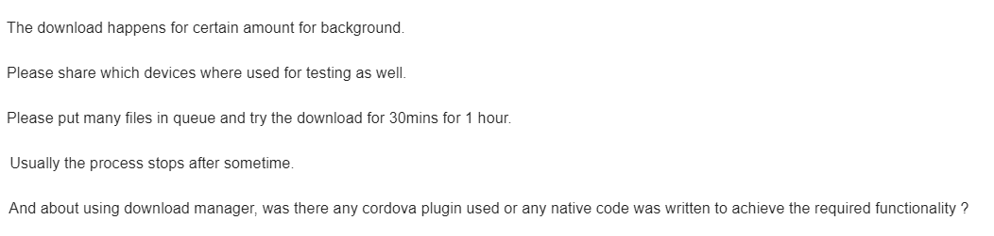

* So we wanted to upload bigger files and test for them. So we uploaded a 440 MB file and tested it. The download took about 10 minutes to complete and other details of the download are mentioned down in the report.
* Shifted our other sample zip files to firebase now comprises of 440 MB file, 270 MB file and a 110 MB file.
* Modified the application to accommodate the same i.e. to download multiple files at the same time.
* Even the combination of files could not accommodate the 1hr interval. As the speed could not be reduced to less than 20 mbps.
* When we tried to download multiple instances of same files we were not allowed since firebase has a daily limitation of 1GB download per day.
* So we limited the internet speed to 2G and downloaded a succession of 4 10 MB files simultaneously. It took about 52 minutes but still wasn’t possible to reach one hour mark.
* We then found an internet source for random test files to download.
* We choose a 1 GB file and tested it with the second app we have created.
* We downloaded 8 instances of the same 1 GB file download took about 1 hour and 12 minutes. We couldn’t afford to download more as the mobile ran out of memory space.
* For the final question as we mentioned earlier we used a Cordova plugin for downloading the files.

**Initial report based on the first app**

Tested the application in multiple devices and successfully downloaded files greater than 50 MB.

We made frequent changes to the app for testing in various scenarios.

Tested the app under different scenarios by changing file sizes, network speed and by using different android devices.

We changed network to 2G, 3G, 4G etc., We tabulated the observed results.

|  |  |  |  |  |  |
| --- | --- | --- | --- | --- | --- |
| **File Size** | **Time Taken (min)** | **Phone Brand** | **Network Mode** | **Source** | **Bandwidth** |
| 440 MB | 10 | Poco F1 | 4G /2.5 GHZ | Firebase | 20Mbps |
| 10 MB | <1 | Poco F1 | 4G / 5 GHZ | Firebase | 250Mbps |
| 8 GB ( 8 X 1GB) | 72 | Poco F1 | 4G /2.5 GHZ | Online | 20Mbps |
| +440+270+110 MB | 25 | Poco F1 | 4G /2.5 GHZ | Firebase | 20Mbps |
| 440+270+110 MB | 10 | Redmi Note 5 | 4G | Firebase | 20 Mbps |
| 10MB+10MB+10MB  +10MB | 50 | Redmi Note 5 | 2G | Firebase | 0.1 Mbps |
| 4 x 10 MB | 45 | Redmi 5 | 2G | Firebase | 0.2 Mbps |

**Based on the second version:**

**Firebase Limitations:**

* 30 GB storage
* Maximum allowed 1GB / day for downloading from server. Resets every day.

**Test Conditions:**

* Queued all downloads in the beginning.
* Downloaded multiple zip files at the same time.
* Pushed the app to the background and also turned off the phone.
* Tested under poor network connectivity (2G).
* Tested with good network connectivity (5G).

**Limitations we faced:**

Sudharshan R:

* I had a good internet connection but could not limit its speed. Since I am a JIO subscriber, limiting the internet bandwidth won’t work. So I downloaded the larger files.

Dhayanidhi V:

* Limited internet available. But I was able to change the speed to 2G/ 3G/ 4G.

Aadhithyan P:

* Limited internet available. But I was able to change the speed to 2G/ 3G/ 4G.

**Final version of the app:**

https://drive.google.com/file/d/1_aaMOTEdDcAVygGQLGQd4GFSH1zQwSzE/view?usp=sharing